EXPERIMENT 7

Text Generation using Google Gemini LLM API

Name | N.Vinay Yadav
Register Number | 192472061

AIM
To demonstrate text generation for a prompt using a sample Google Gemini-style response.

PROCEDURE
- Open a Python editor or notebook.
- Display a predefined prompt asking about Machine Learning.
- Prepare a sample response explaining Machine Learning.
- Print the prompt and generated response.
- Execute the program and observe the output.

PROGRAM
print("Text Generation using Google Gemini LLM API")

prompt = "What is Machine Learning?" print("\nPrompt:", prompt)

generated_text = """
Machine Learning is a branch of Artificial Intelligence that allows computers to learn from data and make predictions without being explicitly programmed.
"""

print("\nGenerated Response:") print(generated_text)

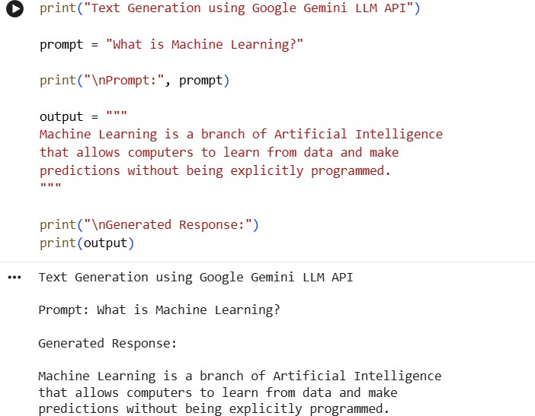
OUTPUT

RESULT
Thus, the program demonstrating text generation using a Gemini-style prompt was executed successfully.

